How do I stop and start Amazon EC2 instances at regular intervals using AWS Lambda.
CloudWatch Event that triggers your Lambda function

STEP 1:- Open the AWS Lambda console, and choose Create function.
--->Choose Author from scratch
--->Enter a Name for your function, such as "StopEC2Instances."
--->From the Runtime drop-down menu, choose Python2.7
--->Expand the Role drop-down menu, and then choose Create a custom role. This opens a
new tab or window in your browser.
--->In the IAM Role drop-down menu, choose Create a new IAM Role, and enter a Role
Name, such as “lambda_start_stop_ec2."
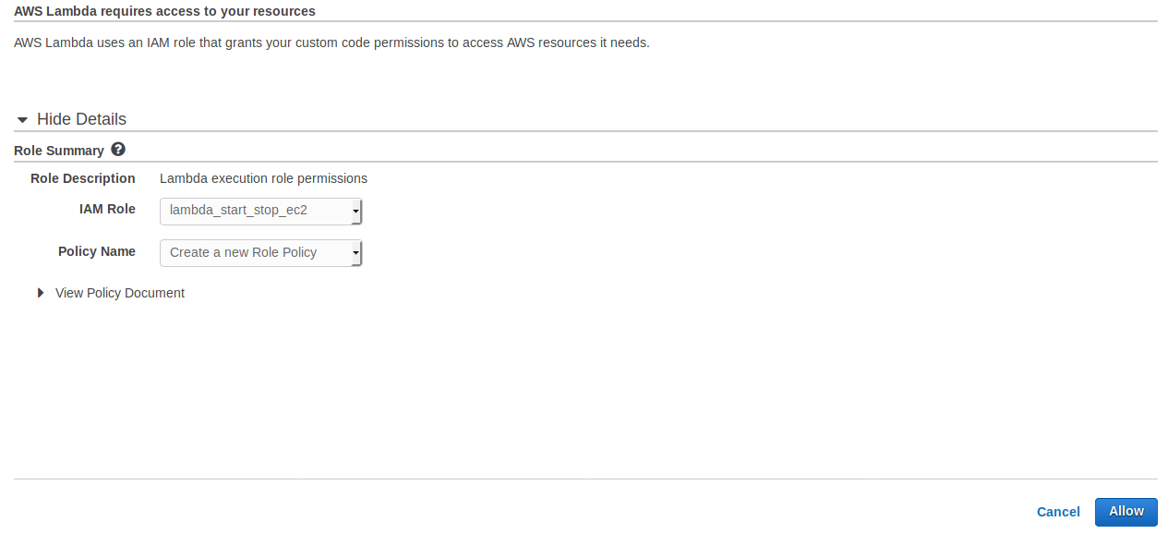
--->Expand View Policy Document, choose Edit, and then choose Ok when prompted to read
the documentation. Edit the policy as follows:

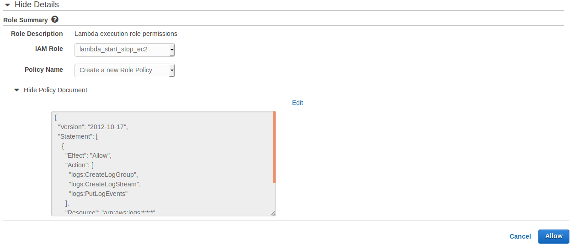
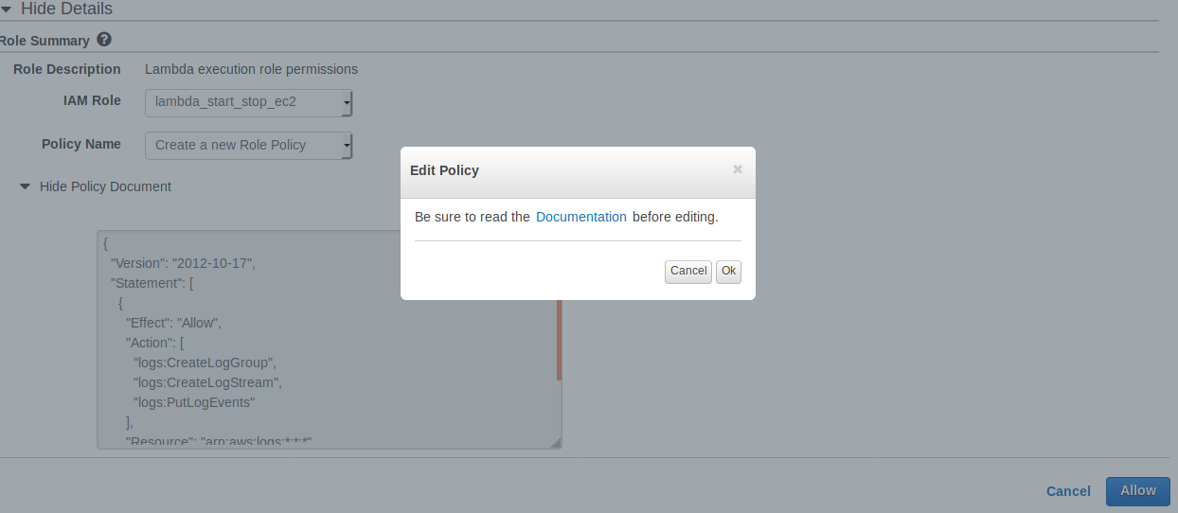
---> Copy the below syntax into Hide Policy Documents,

{
"Version": "2012-10-17",
"Statement": [
{
"Effect": "Allow",
"Action": [
"logs:CreateLogGroup",
"logs:CreateLogStream",
"logs:PutLogEvents"
],
"Resource": "arn:aws:logs:*:*:*"
},
{
"Effect": "Allow",
"Action": [
"ec2:Start*",
"ec2:Stop*"
],
"Resource": "*"
}
]
}

--->Choose Allow to complete the role and return to the AWS Lambda console, and then
choose Create Function.
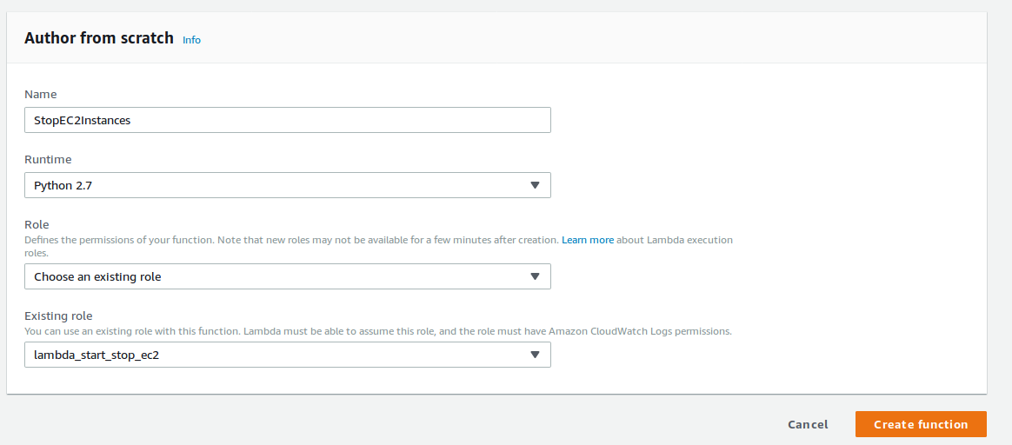
----> Select Create function.
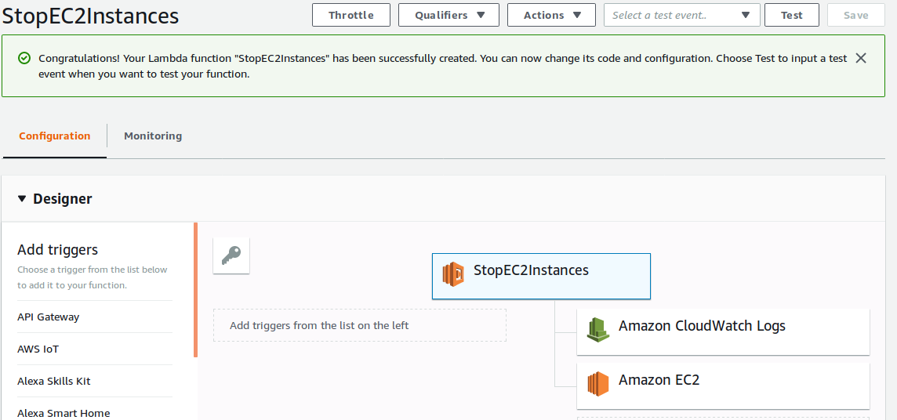

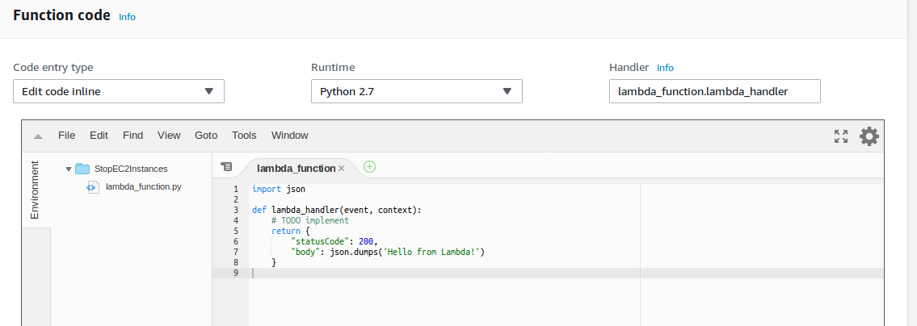
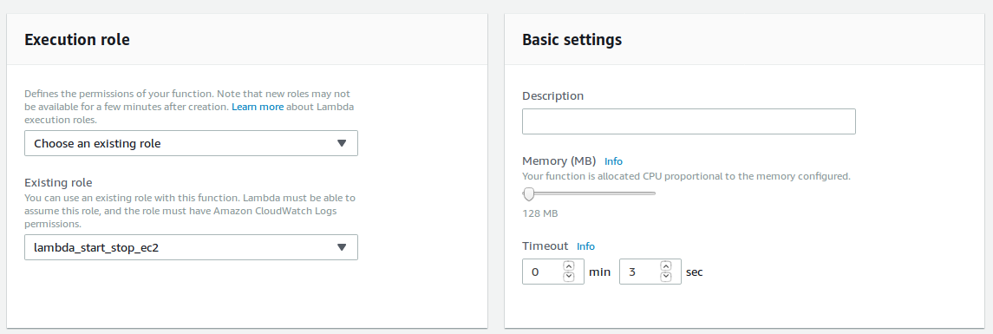
--->To stop your instances, enter the following into the Function code editor:

import boto3
# Enter the region your instances are in. Include only the region without specifying Availability Zone; e.g., 'us-east-1'
region = 'XX-XXXXX-X'
# Enter your instances here: ex. ['X-XXXXXXXX', 'X-XXXXXXXX']
instances = ['X-XXXXXXXX']

def lambda_handler(event, context):
ec2 = boto3.client('ec2', region_name=region)
ec2.stop_instances(InstanceIds=instances)
print 'stopped your instances: ' + str(instances)

--->In this code modify only “region” and “Instances”
import boto3
# Enter the region your instances are in. Include only the region without

specifying Availability Zone; e.g., 'us-east-1'

region = 'eu-west-1'
# Enter your instances here: ex. ['X-XXXXXXXX', 'X-XXXXXXXX']

instances = ['i-01de5f9620377b896']

def lambda_handler(event, context):
ec2 = boto3.client('ec2', region_name=region)
ec2.stop_instances(InstanceIds=instances)
print 'stopped your instances: ' + str(instances)

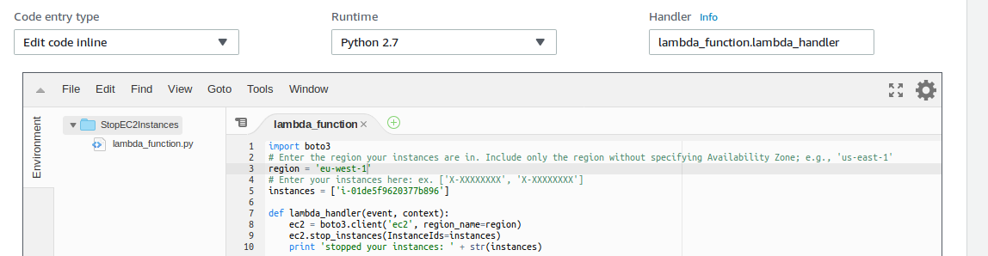

---> In Basic settings, enter 10 seconds for the function Timeout.
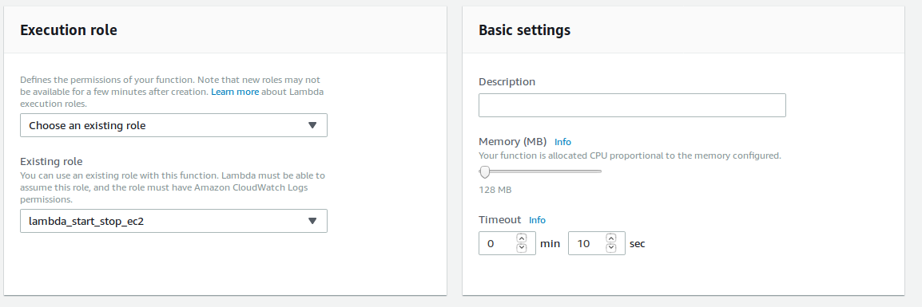
--->Choose Save.

--->Test your functions:-
--->Open the AWS Lambda console, and then choose Functions.
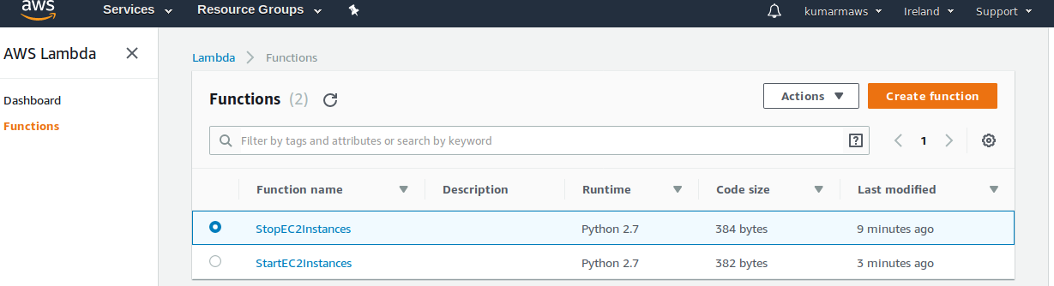
---> Select your “StopEC2Instances” function.
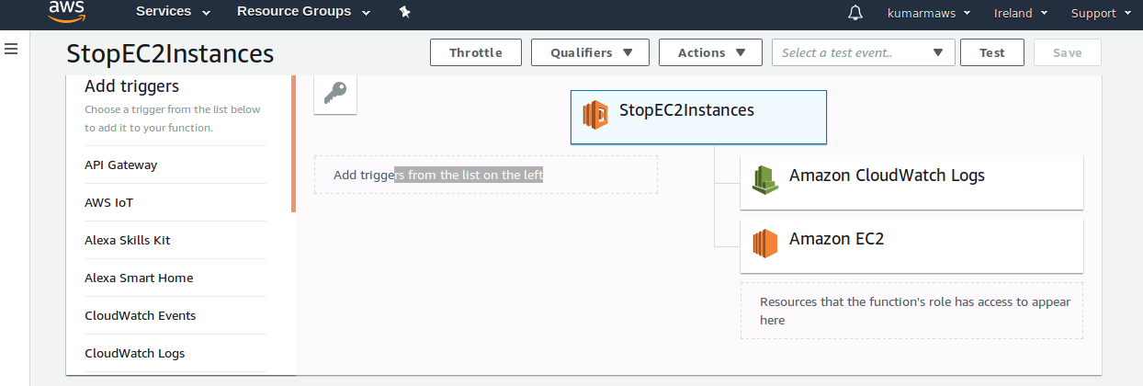

---> Select “Test” Top right Corner --->It will come like below,
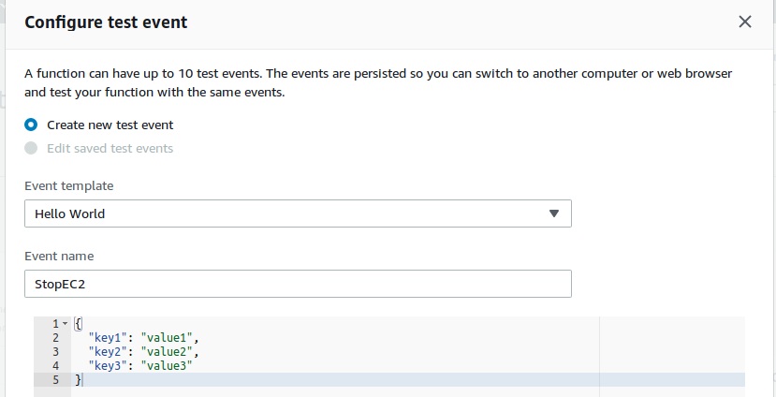
---> Select Create.
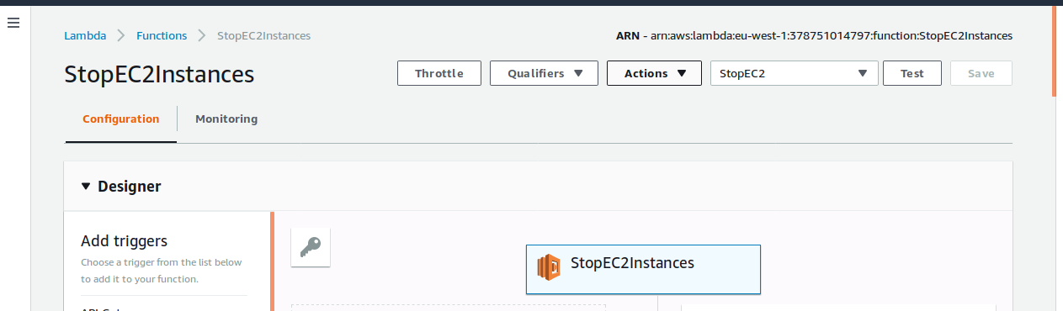
--->Now Select “Test” to execute the function.

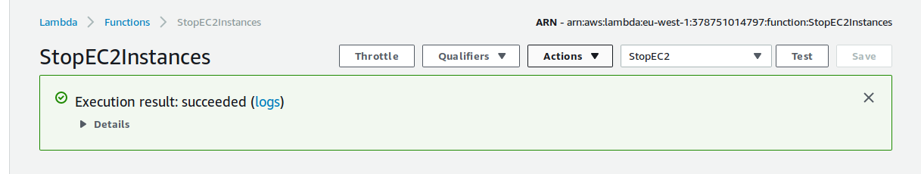
---> Goto AWS Console---> See the function output server stopped through lamda function.
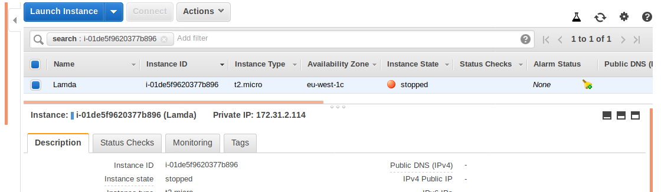
==>Create a CloudWatch Event that triggers your Lambda function.

---> Goto AWS Console--> Select Services---> Select CloudWatches-->left side panel Select
Events---> and select Create rule.
---> Choose Schedule under Event Source.
--->Enter an interval of time or cron expression that tells Lambda when to stop your
instances. For more information on the correct syntax, see Schedule Expression Syntax
for Rules.
--->Note: Cron expressions are evaluated in UTC. Be sure to adjust the expression for your
preferred time zone.
--->Choose Add target, and then choose Lambda function.
--->
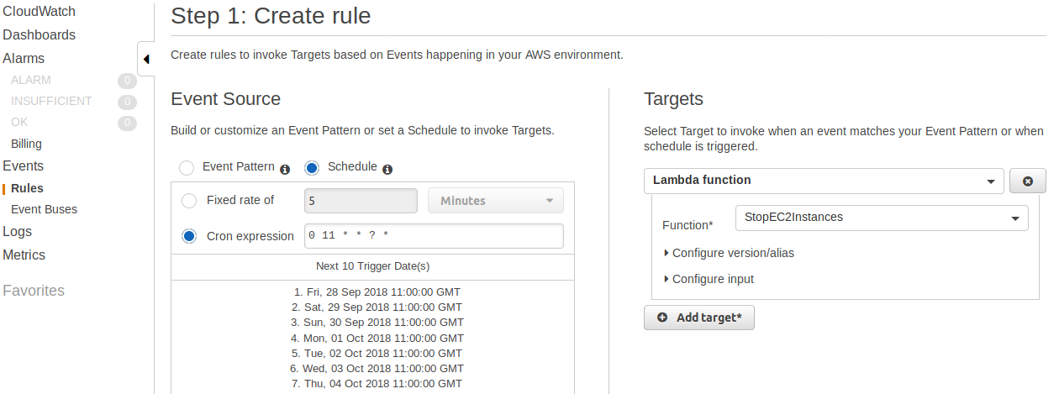
---> Select Configure Details.
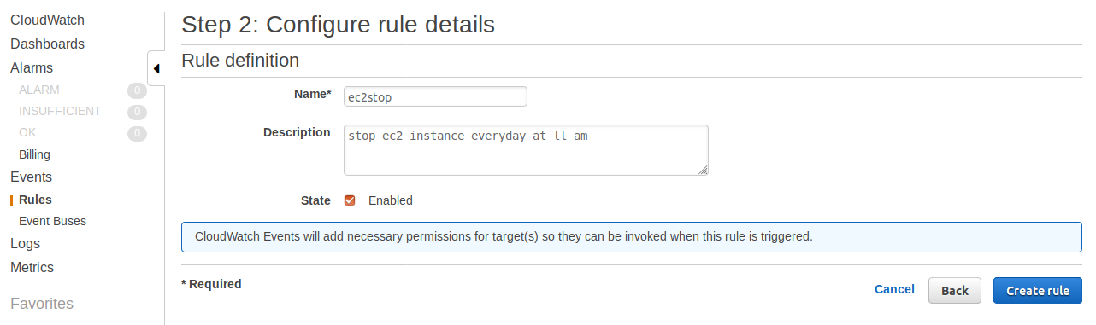
---> Select Create rule.

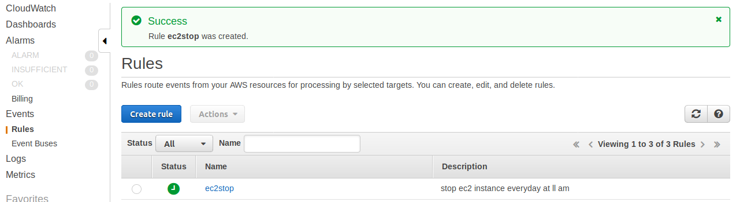

---> Goto AWS Console and see the stauts of ec2-instance is stopped (Cloudwatch event triggered for 11.00 AM UTC)
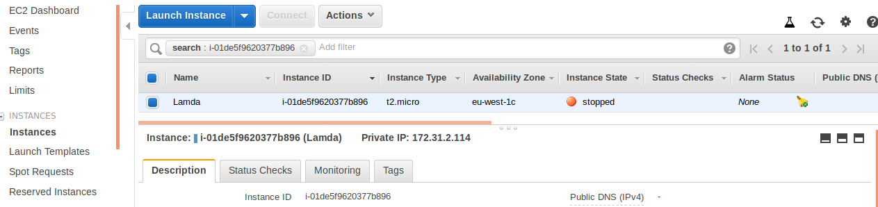

--->Repeat these steps to create another function that starts your instances again by using the
following: (ex: StartEC2Instances)
---->(Repeat allow above steps to create another function Ex:StartEC2Instances).

Reference link :-

https://aws.amazon.com/premiumsupport/knowledge-center/start-stop-lambda-cloudwatch/

